PALO ALTO FIREWALL LAB REPORT
Group 6 — Configure Default Route on Palo Alto towards ISP
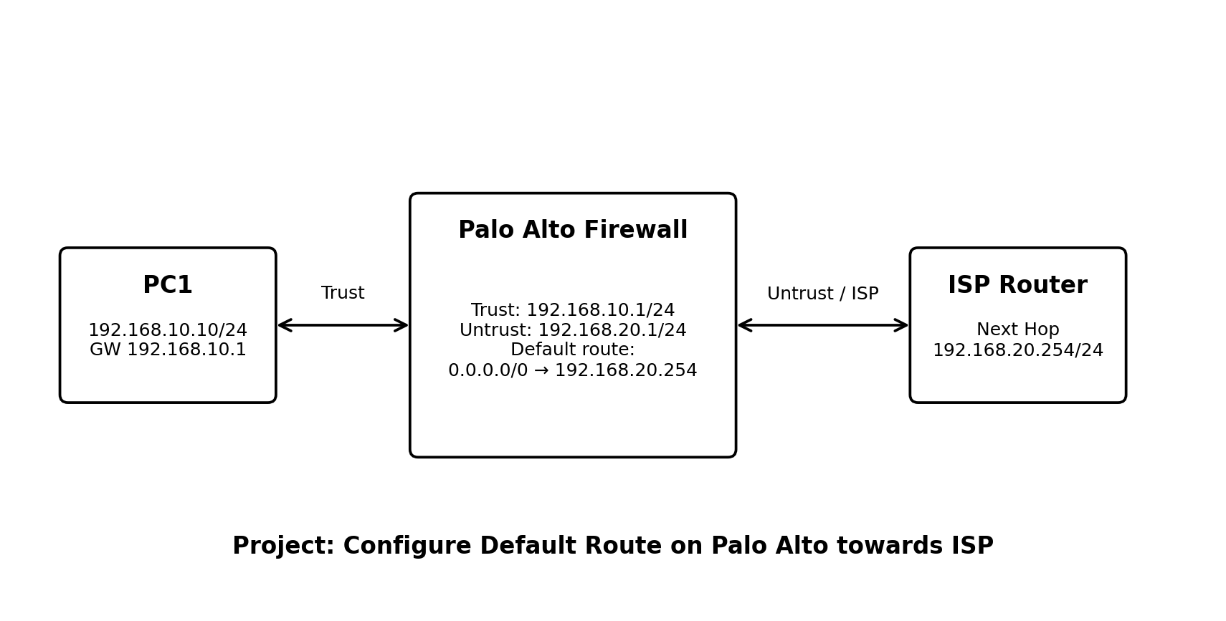
Figure 1. Project topology reference.

1. Project Objective
The objective of this lab is to configure and verify a default static route on a Palo Alto Firewall towards an ISP. The firewall uses the default route 0.0.0.0/0 to forward traffic for destinations that are not covered by a more-specific route.

2. Network Topology and IP Addressing
Device | Role | Interface | IP Address | Zone
PC1 | Trust Host | — | 192.168.10.10/24 | Trust
Palo Alto | LAN / Trust | Ethernet1/1 | 192.168.10.1/24 | Trust
Palo Alto | WAN / Untrust | Ethernet1/2 | 100.1.1.2/24 | Untrust
ISP | Upstream Next Hop | — | 100.1.1.1/24 | —
PC1 uses 192.168.10.1 as its default gateway. The Palo Alto Untrust interface uses 100.1.1.2/24, and the ISP next-hop gateway is 100.1.1.1.

3. What is a Default Route?
A default route is the route 0.0.0.0/0. It is used when the routing table does not contain a more-specific route for the destination. In this project, the Palo Alto sends such traffic to the ISP next hop 100.1.1.1 through the Untrust interface.

4. Main Configuration
Field | Value
Virtual Router | default
Route Name | DEFAULT-TO-ISP
Destination | 0.0.0.0/0
Next Hop | 100.1.1.1
Interface | Ethernet1/2 / Untrust
Admin Distance | 10
Metric | 10

5. Palo Alto GUI Configuration

Step 1 — Configure the Trust Interface
Go to Network > Interfaces > Ethernet. Configure Ethernet1/1 as Layer3, assign 192.168.10.1/24, select the default virtual router, and place the interface in the Trust zone.

Step 2 — Configure the Untrust Interface
Configure Ethernet1/2 as Layer3, assign 100.1.1.2/24, select the default virtual router, and place the interface in the Untrust zone.

Step 3 — Create or Verify Security Zones
Go to Network > Zones. Verify that Ethernet1/1 is in Trust and Ethernet1/2 is in Untrust.

Step 4 — Configure the Default Route
Go to Network > Virtual Routers > default > Static Routes > IPv4. Add DEFAULT-TO-ISP with destination 0.0.0.0/0 and next hop 100.1.1.1 through the Untrust interface.

Step 5 — Commit
Review the candidate configuration and click Commit. The committed configuration becomes active.

6. Security Policy
A default route only provides a routing path. It does not automatically permit traffic through the firewall. For Trust-to-Untrust communication, create a Security Policy appropriate to the lab requirement.
Policy Field | Recommended Lab Value
Rule Name | TRUST-TO-UNTRUST
Source Zone | Trust
Destination Zone | Untrust
Source Address | PC1 or 192.168.10.10
Destination Address | any, or required test destination
Application | ping / required applications
Service | application-default
Action | Allow

7. ISP Return Route
For the ISP or upstream simulator to return traffic to PC1, it must know that 192.168.10.0/24 is reachable through the Palo Alto Untrust address.
ISP return route: 192.168.10.0/24 → next hop 100.1.1.2.

8. NAT for Internet Access
A default route alone does not provide Internet access for a private address such as 192.168.10.10. If the lab requires Internet or public-network access, configure Source NAT from Trust to Untrust. A common lab design uses Dynamic IP and Port with the Untrust interface address as the translated address. The exact NAT design depends on the upstream simulator.

9. Verification
- Check the routing table and confirm a default route equivalent to 0.0.0.0/0 → 100.1.1.1.
- Ping the ISP next hop from the Palo Alto using the Untrust source address.
- From PC1, test the required destination after Security Policy and NAT are configured.
- Use the PAN-OS Traffic log to confirm the session, action, source, destination, and application.
- Use a FIB lookup for an external address such as 8.8.8.8 to confirm that the default route is selected.

10. Useful CLI Verification
show routing route
show routing route type static
show routing route destination 0.0.0.0/0
ping source 100.1.1.2 host 100.1.1.1
test routing fib-lookup virtual-router default ip 8.8.8.8
show session all filter source 192.168.10.10

11. Expected Result
The Palo Alto routing table contains a default route equivalent to 0.0.0.0/0 via 100.1.1.1 through the Untrust interface. When a destination does not have a more-specific route, the firewall selects this default route. Successful end-to-end connectivity additionally requires the correct Security Policy, NAT when needed, ISP return routing, and upstream connectivity.

12. Troubleshooting
- Cannot ping 100.1.1.1: check Ethernet1/2 IP address, link status, zone, and ISP-side addressing.
- Default route is missing: check the virtual router and static route configuration, then commit.
- Route exists but PC1 cannot reach an external destination: check Security Policy, NAT, ISP return route, and upstream connectivity.
- Traffic is denied: inspect the Traffic log and confirm the matching Security Policy rule.
- PC1 cannot reach the firewall: check PC1 IP address, subnet mask, and default gateway.

13. Conclusion
This lab demonstrates how a Palo Alto Firewall uses a default static route to forward unknown or external traffic towards an ISP. The key configuration is 0.0.0.0/0 with next hop 100.1.1.1 through the Untrust interface. The lab also shows that routing, Security Policy, NAT, and return routing are separate but related parts of end-to-end connectivity.

14. Evidence for Final Submission

